From Commcell Console

* Right Click highlighted, All Tasks, Add/Remove Software, Install Software

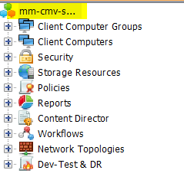

Install Wizard Pop-Up

* Select Next

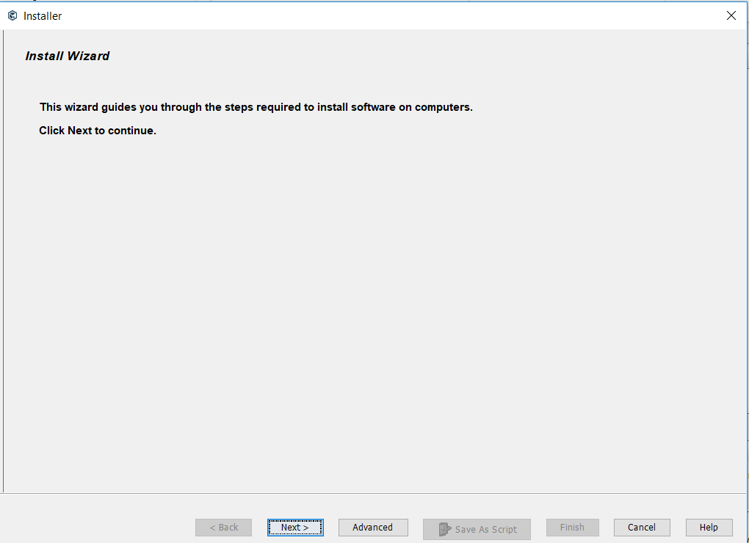

* Select Windows, Click Next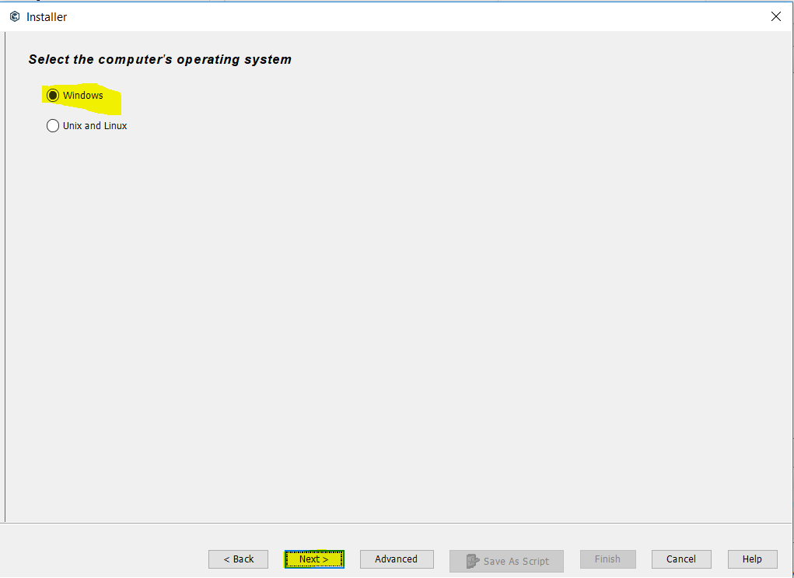
* Select Manually select Computers, Click Next

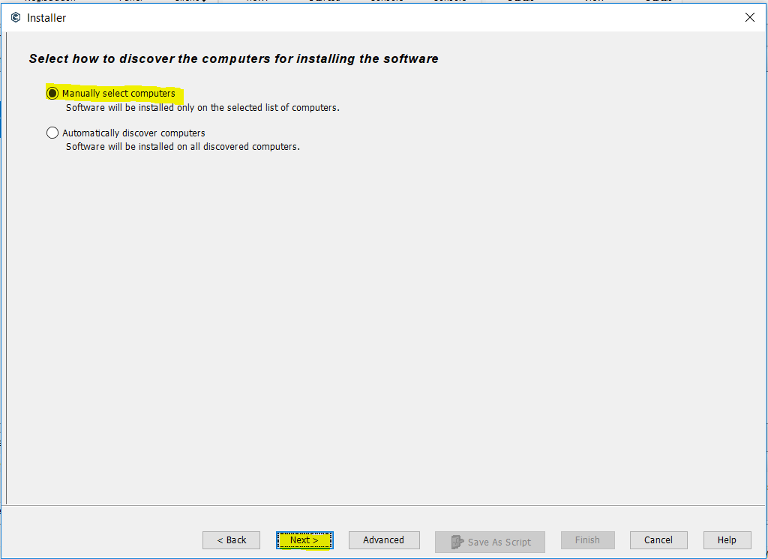

* Type server name, click next

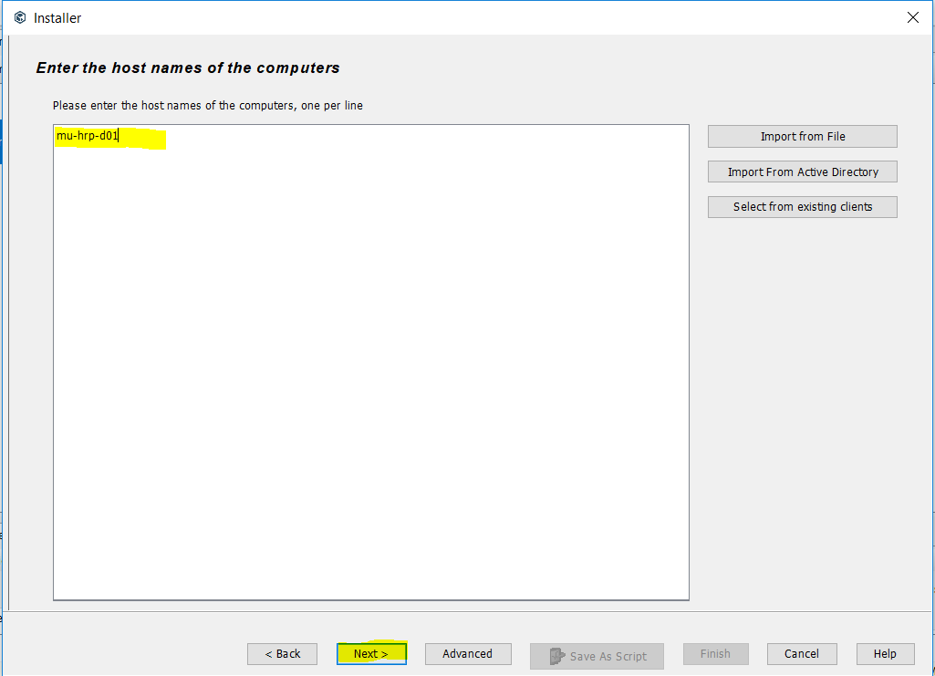

* Enter in your adm account username/password, click next

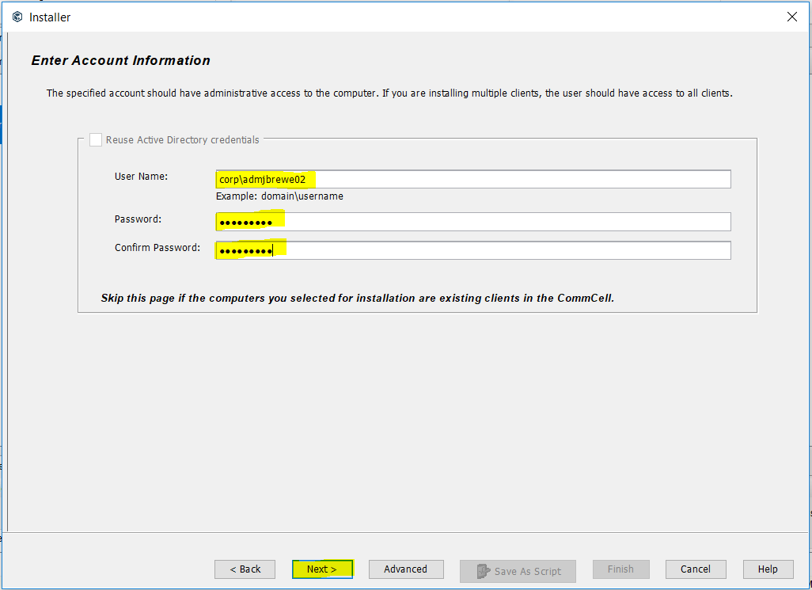

* Select File System Core, File System, SQL Server, click next

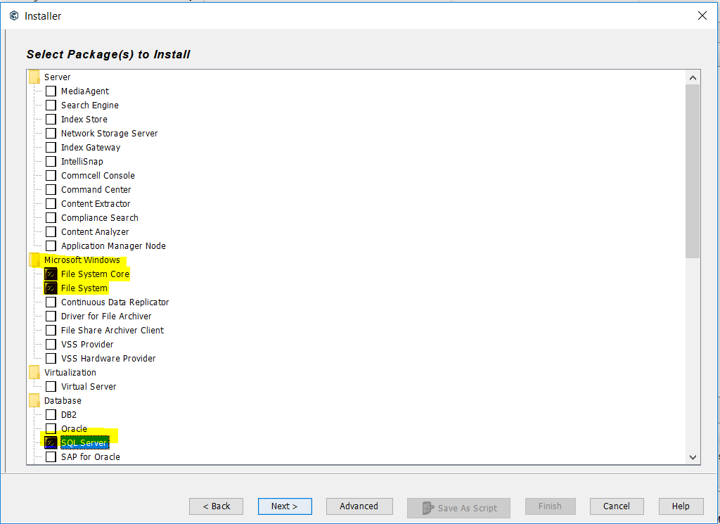

* Click Next on this screen

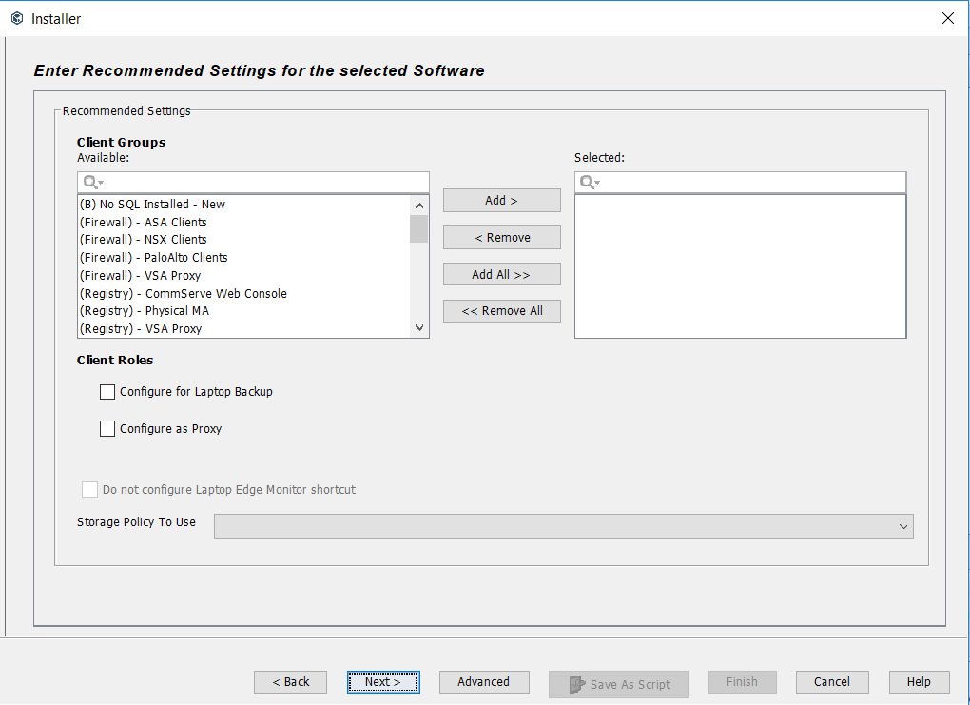

* Click Next on this screen

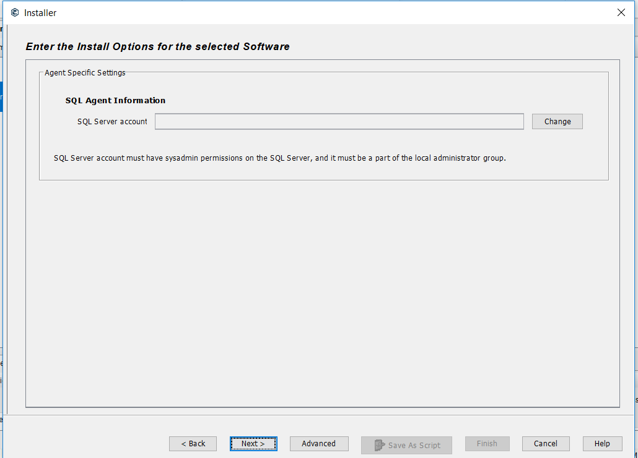

* Click Next on this screen

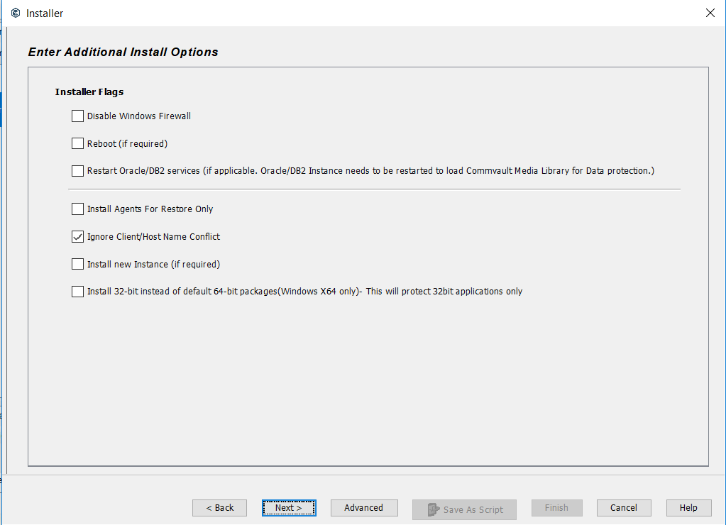

* Install to folder D:\Program Files\Commvault\Simpana

CommServe Override commserve.corp.net.bcbsaz.com

Click Next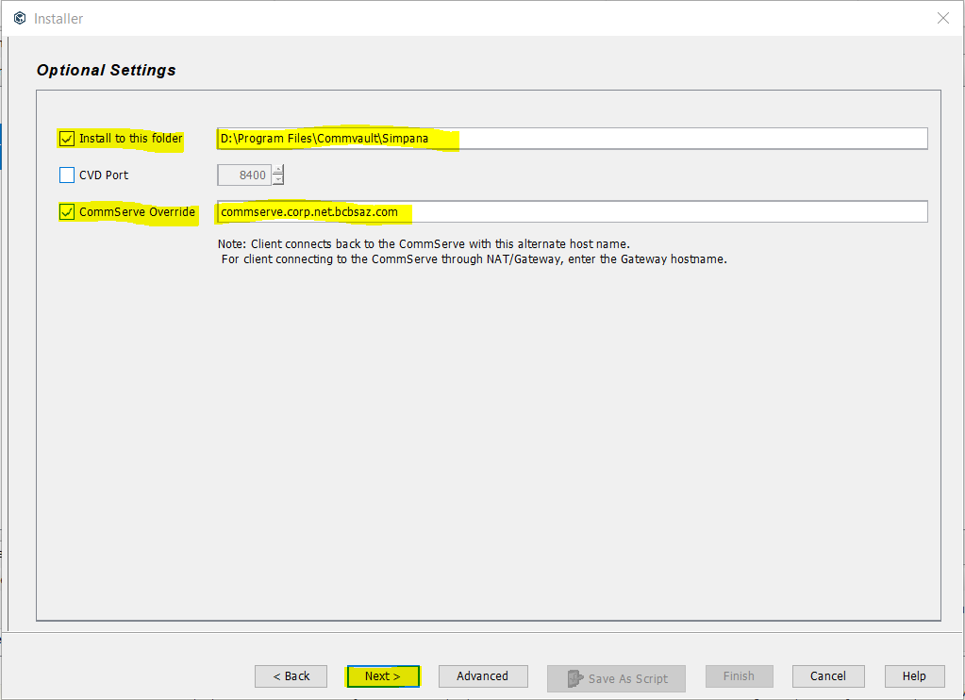

* Click Next

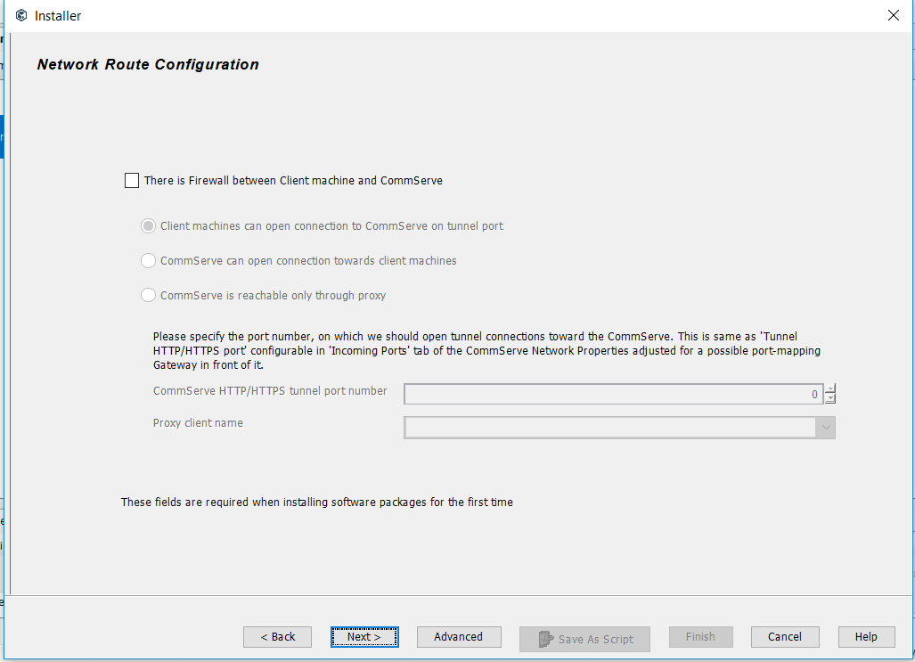

* Select Immediate, Click Next

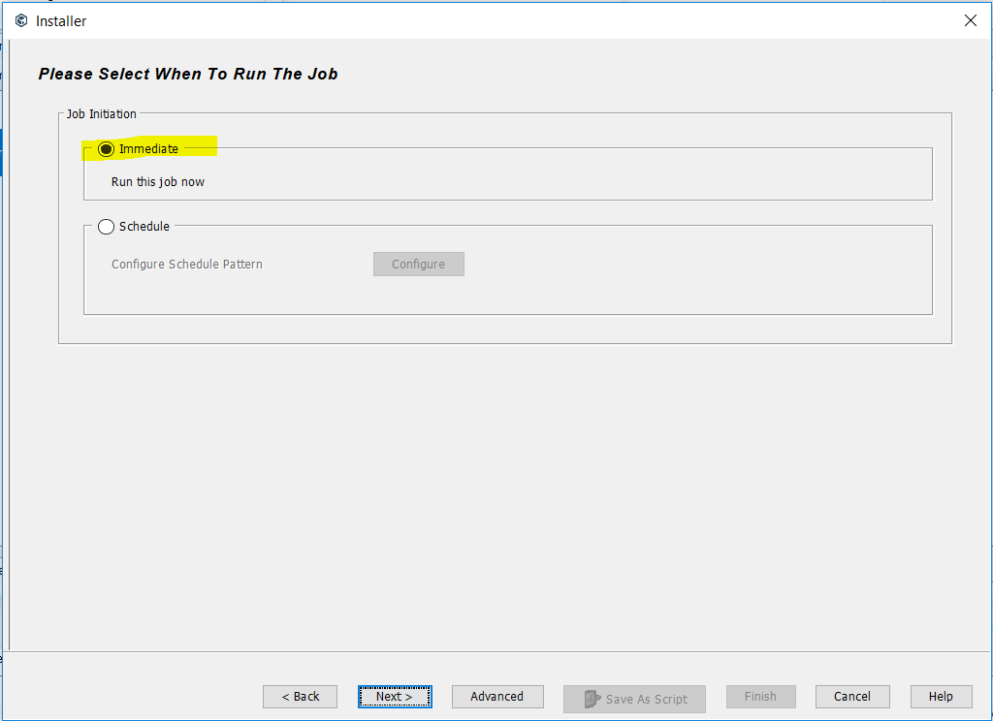

* Summary Page appears, scroll to the bottom to double check it, Click Finish

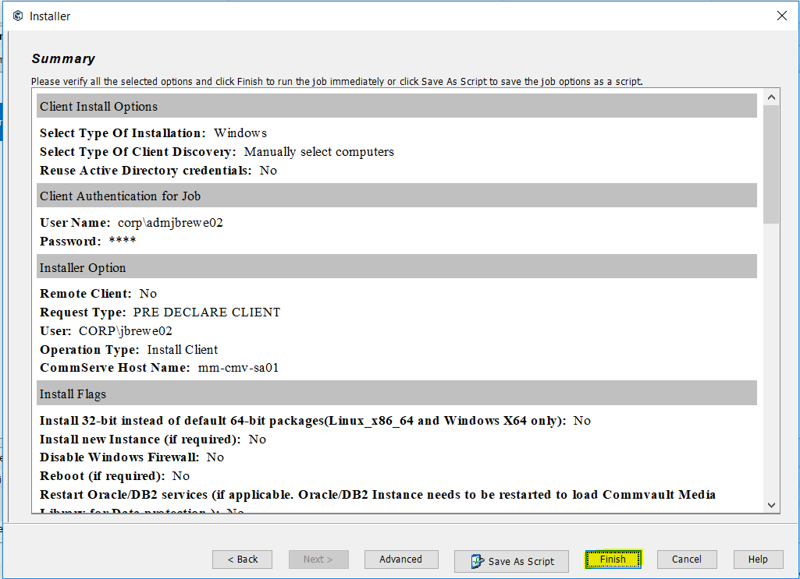

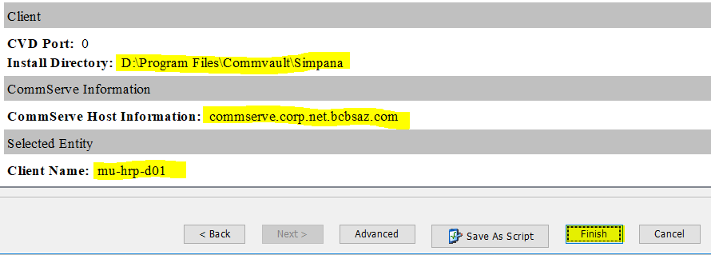

* Go to Commvault job controller and verify the job is running

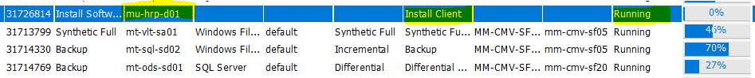

* After Commvault job completes, log onto server, go to D:\Program Files\Commvault\Simpana to be sure the install folders are there.